**CPSC 50900 Database Systems Project**

**Initial Proposal**

The Idea here is to generate the policy ID and then determine which insurance policy is applicable for which person.

**Description Data**

The data will be divided into four columns namely Customer, Payment, Policy, Claims and Driver. These will be having fields of its own.

The Customer table will have a policy id which is the primary key, customer name, the date of birth, the address and the payment type.

The Payment table has the policy id which is the foreign key, they payment type which is the primary key, the payment account, routing and checknum.

The Policy table will contain the policy id as the foreign key, the policy plan as primary key and the policy price.

The Claims table has the Policy ID which is a foreign key, the Claims ID is the Primary Key, the Claims Date and the DOC_ID are the other fields here

The last one is the Drivers table containing the Policy ID, Policy Plan, Drivers Licenses and History

**Relational Database Design**

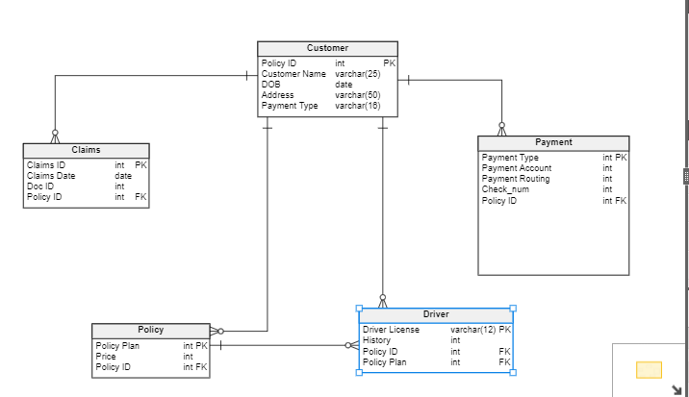

**Screenshots**

